A Data Science Approach to

Forecast Electricity Consumption in Australia

Brendan Chick (z5632728),
Daniel Heath-Ogden (z5623647),
Kam Kit Lau (z5618444),
Kelvin Yim (z5502200).
24/03/2026

Table of Contents
1 Introduction and Motivation 3
2 Preliminary Literature Review 3
3 Methods, Software and Data Description 4
4 Activities and Schedule 5
5 Team Roles 5
Appendix 1 - Expected Contribution 6
Appendix 2 – Expertise of Team Membrers 6
References 6

1 Introduction and Motivation
Accurate electricity demand forecasting is critical for energy planning, grid stability, and efficient electricity market operations. Electricity providers must estimate future demand in order to schedule generation, allocate resources, and maintain system reliability. Inaccurate forecasts may lead to power shortages, inefficient generation scheduling, or unnecessary operational costs.
This project focuses on forecasting electricity demand in New South Wales (NSW), Australia using historical electricity demand data. The main objective is to evaluate the effectiveness of modern machine learning models for predicting future electricity demand and to compare them with traditional statistical forecasting approaches.
Electricity demand is influenced by multiple factors including seasonal trends, daily consumption patterns, weather conditions, and behavioural patterns of electricity users. These characteristics make electricity demand forecasting a complex time-series problem.
In this project we focus on long-horizon forecasting, where multiple future time steps are predicted simultaneously. Specifically, we aim to forecast 55 days of electricity demand at a time. This type of forecasting is relevant for real-world planning where decision makers require forecasts covering extended future periods.
The main research question of the project is:
Can transformer-based models improve long-horizon electricity demand forecasting accuracy compared with traditional statistical models and recurrent neural networks?
To answer this question, we will compare three different forecasting approaches:
- SARIMAX, a classical statistical time-series model
- LSTM, a recurrent neural network designed for sequential data
- PatchTST, a transformer-based deep learning architecture for time-series forecasting
By comparing these models, the project aims to evaluate whether modern deep learning archi-tectures can provide meaningful improvements in electricity demand forecasting performance.

2 Preliminary Literature Review
Electricity demand forecasting has traditionally relied on statistical time-series models such as ARIMA and SARIMA (Box et al., 2015). These models are widely used because they are interpretable and effective at modelling trend and seasonal patterns in time-series data. SARIMAX extends these models by incorporating external explanatory variables such as weather conditions. However, classical statistical models may struggle when nonlinear relationships exist in the data or when long-range temporal dependencies must be captured.
In recent years, deep learning models have been increasingly applied to forecasting tasks. Long Short-Term Memory (LSTM) networks are particularly popular because they can learn sequential dependencies in time-series data. LSTM networks introduce gating mechanisms that allow the model to retain information across longer time intervals (Hochreiter & Schmidhuber, 1997). Despite these advantages, LSTM models still process data sequentially, which may limit their ability to efficiently capture long-range dependencies.
More recently, transformer architectures have been introduced for time-series forecasting. Transformers use attention mechanisms rather than sequential processing, allowing them to capture relationships between distant time points more effectively. Several recent studies have shown that transformer-based models perform well in long-horizon forecasting tasks.
PatchTST (Nie et al., 2023) is a transformer-based model specifically designed for time-series forecasting. Instead of processing each time step individually, PatchTST divides the time series into fixed-length patches. This approach reduces the sequence length and allows the model to learn temporal patterns more efficiently.
Based on existing literature, transformer models are expected to perform well in long-horizon forecasting problems. In this project, PatchTST will be evaluated alongside SARIMAX and LSTM to determine whether it provides improved predictive performance for electricity demand forecasting.

3 Methods, Software and Data Description
3.1 Research Question - The main research question of this project is:
Can the PatchTST transformer model produce more accurate long-horizon forecasts of NSW electricity demand compared with SARIMAX and LSTM models?
Specifically, we will evaluate the performance of these models when predicting 55 days of future electricity demand in a single forecast.
3.2 Data - The dataset used in this project consists of historical electricity demand data for New South Wales (NSW) covering approximately the past ten years.
The main variable of interest is Electricity demand (MW).
Additional explanatory variables may include:
- Time within a day, day within a week, month of a year
- Temperature
These variables may improve forecasting accuracy by capturing seasonal and behavioural patterns in electricity consumption. The dataset will be divided into three segments - training set (60%), validation set (20%) and test set (20%).
Exploratory Data Analysis (EDA) will be conducted to examine seasonal patterns, daily demand cycles, and the relationship between temperature and electricity demand.
3.3 Forecasting Design - The forecasting approach used in this project is multi-step single-shot forecasting. The model observes historical electricity demand within an input window and predicts the next 55 days of demand simultaneously.
This approach differs from rolling one-step forecasting and better reflects real-world planning situations where forecasts are required for longer future horizons.
3.4 Models
SARIMAX - a classical statistical forecasting model capable of modelling seasonal patterns, trends, and external variables. It will serve as the baseline model for comparison.
LSTM - a recurrent neural network designed to capture temporal dependencies in sequential data. The model contains memory cells and gating mechanisms that allow it to learn long-term relationships in time-series data.
PatchTST - a transformer-based model designed specifically for time-series forecasting. The model divides the input time series into smaller segments (patches) and processes them using transformer layers. PatchTST has the following key advantages:
- improved ability to capture long-range dependencies
- efficient modelling of long input sequences
- strong performance in long-horizon forecasting tasks
3.5 Evaluation Metrics - Model performance will be evaluated using Root Mean Square Error (RMSE) and Mean Absolute Error (MAE), which allows quantitative comparison of forecasting accuracy across different models.
3.6 Software - The project will primarily use Python and Google Colab Notebook
Key libraries will include pandas, numpy, matplotlib, scikit-learn, statsmodels (for SARIMAX), PyTorch or TensorFlow (for LSTM), PatchTST implementation from open-source repositories
Python is chosen because it provides a flexible environment for implementing both statistical and deep learning models.

4 Activities and Schedule
The team will collaborate through online meetings and shared working environments. Microsoft Teams will be used for group meetings and communication.
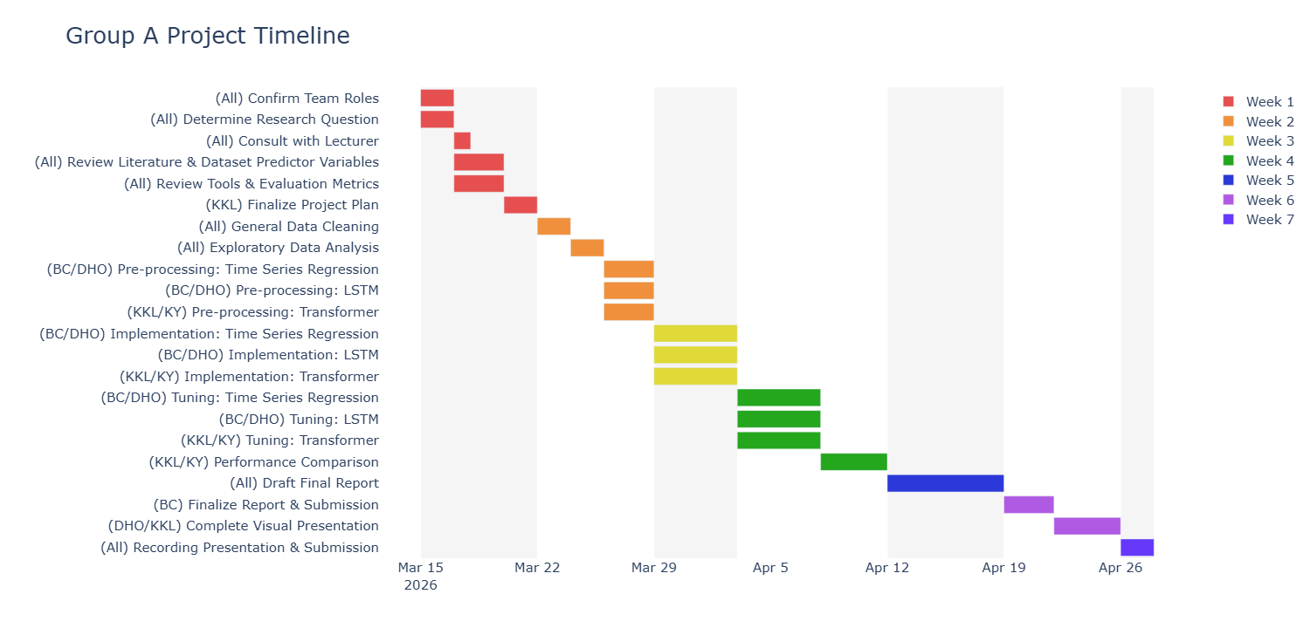

5 Team Roles
Brendan | Research consultant / lead and Model analysis of SARIMAX + LSTM
Daniel | Presentation/Communication Lead and Model analysis of SARIMAX + LSTM
Kam | Project Mgr, Presentation/Communication Lead³ , Model lead of PatchTST + Comparison
Kelvin | Logistics coordinator and Model lead of PatchTST + Comparison
Responsibilities were allocated based on the individual expertise of team members (refer to Appendix 2). Responsibilities may be adjusted depending on schedule and workload distribution.

Appendix 1 - Expected Contribution
This project aims to provide a clear comparison of classical statistical methods, recurrent neural networks, and transformer-based models for electricity demand forecasting.
The main contribution of the project is to evaluate whether modern transformer-based models such as PatchTST provide meaningful improvements in long-horizon forecasting accuracy compared with more traditional approaches.
The results may help illustrate the practical value of transformer architectures in real-world time series forecasting tasks.

Appendix 2 – Expertise of Team Membrers
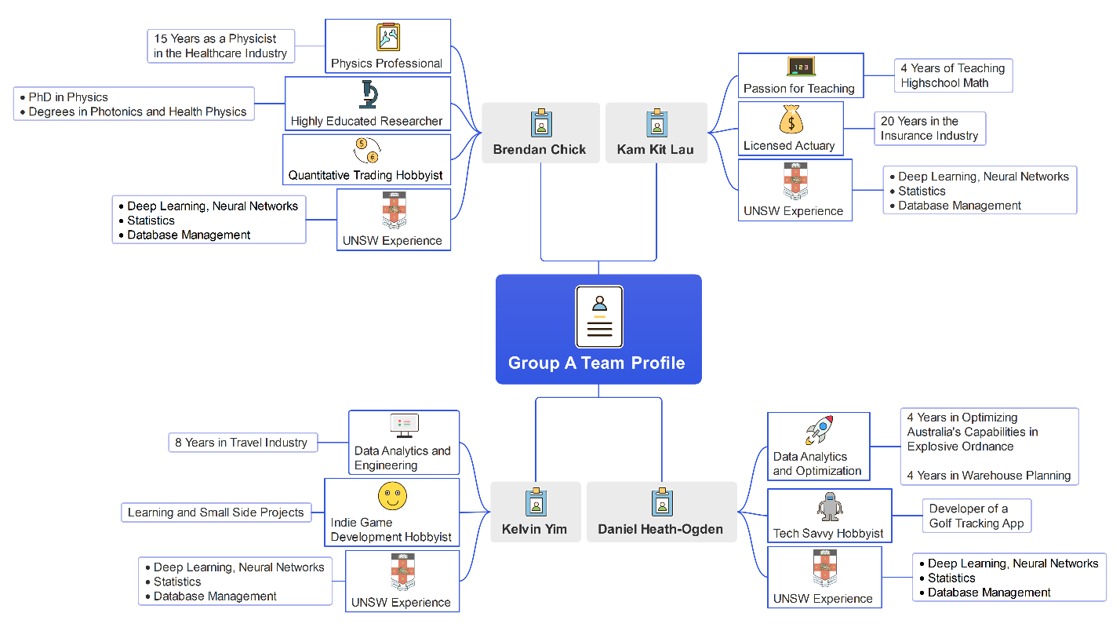

References
1. Box, G. E. P., Jenkins, G. M., Reinsel, G. C. and Ljung, G. M. (2015). Time Series Analysis: Forecasting and Control. Wiley.
2. Hochreiter, S. and Schmidhuber, J. (1997). “Long Short-Term Memory.” Neural Computation, 9(8), pp. 1735–1780.
3. Nie, Y. et al. (2023). “A Time Series is Worth 64 Words: Long-term Forecasting with Transformers.” International Conference on Learning Representations.

Research consultant / lead: driving research direction and scrutinize results (e.g. Train/Validate/Test split, epochs, other hyperparameters), drive direction of research report
Presentation/Communication lead: driving direction and main message of video presentation to meet the objective of delivering the message on how data science approach is applied to solve daily life problem in simple language
Logistics coordinator: Driving discussion, communicate with lecturers, etc

